LEETCODE QUESTION
Add Two Integers - LeetCode
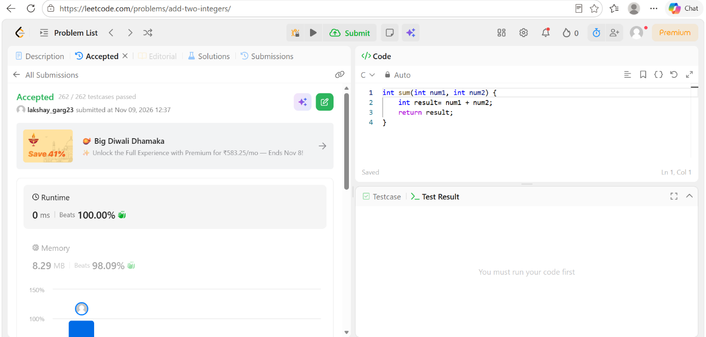

CODE
int sum(int num1, int num2) {
int result= num1 + num2;
return result;
}

